**Method to restore data on localhost Postgresql:**

1. **By terminal (psql)**

Once entered into psql using the command line/terminal you can run the followinf to commands to restore the database ( downloaded file )

1. Createdb acct;
2. pg_restore -e -v -O -x -d aact --no-owner /path/to/data/postgres_data.dmp
3. **By PgAdmin:**

Follow the steps in order of screenshots attached after opening localhost on PgAdmin

1. Right Click on localhost and create custom database

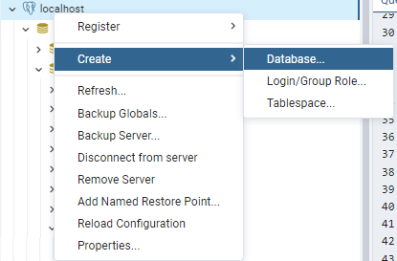

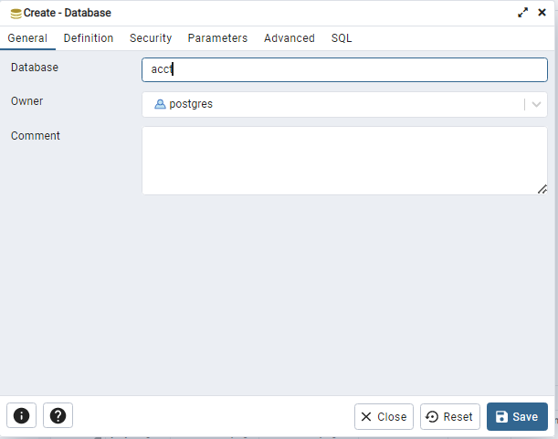

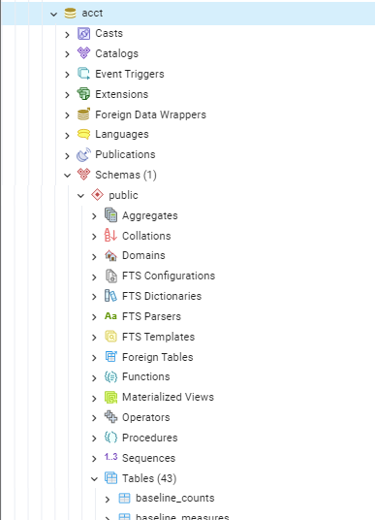

1. Restore your backup file. First right click on the database acct click on Restore. E

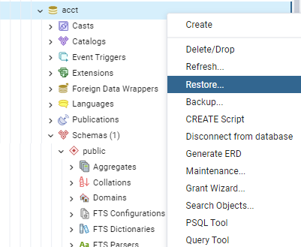

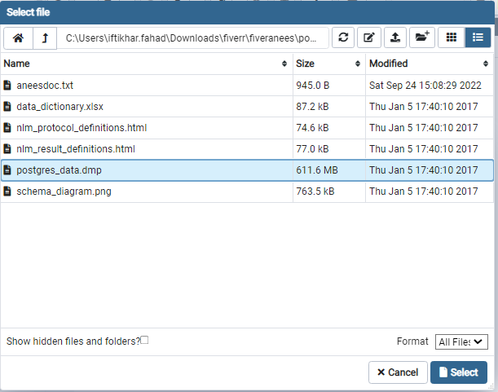

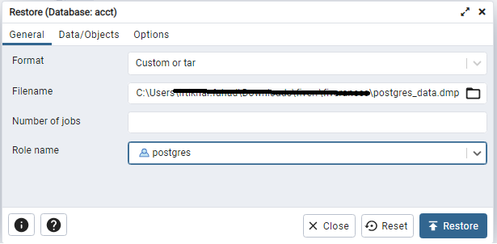

Once done the table section of your restored database will look like this instead of empty. After this we can start querying the data using query builder.

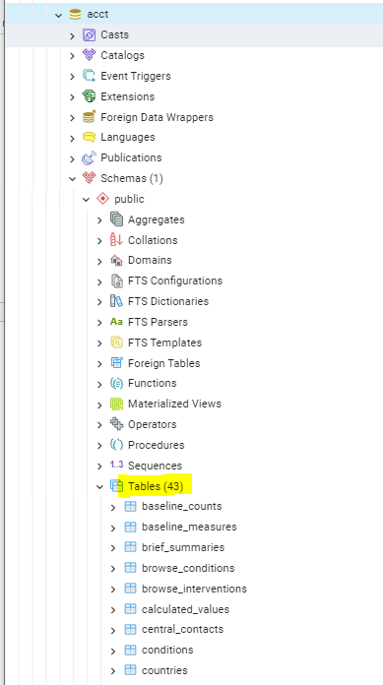

**Queries:**

**1.**

create view trial_details as

select s.nct_id,c.name,e.criteria,f.city || ', ' || f.country as location,i.intervention_type,count(p.id) as total_participants

from studies s join conditions c on s.nct_id=c.nct_id

join eligibilities e on s.nct_id=e.nct_id

join facilities f on s.nct_id=f.nct_id

join interventions i on s.nct_id=i.nct_id

join participant_flows p on s.nct_id=p.nct_id

where s.overall_status='Completed'

group by s.nct_id,c.name,e.criteria,location,i.intervention_type;

**Explanation:**

This query makes a view with name trial_details while joining multiple tables to get desired colums we concat columns city and country of facilities table to give a meaningful location column.We use the participants_flow table to get no of participants per trail in this approach. To access this view you will use another query:

Select * from trial_details;

**2.**

Create view trial_effects as

select s.nct_id,o.outcome_type,r.adverse_event_term from studies s

join outcomes o on s.nct_id=o.nct_id

join reported_events r on s.nct_id=r.nct_id

where r.adverse_event_term is not null;

**Explanation:**

This query makes a view with name trial_effects while joining multiple tables to get desired . To access this view you will use another query:

Select * from trial_effects;

**3.**

select s.nct_id,count(om.id) as patient_count

from studies s join outcomes o on s.nct_id=o.nct_id

join outcome_measures e on o.id=e.outcome_id

join outcome_measurements om on om.outcome_measure_id=o.id

where s.overall_status='Completed'

group by s.nct_id

order by patient_count desc limit 1;

**Explanation:**

This query displays the trial with the most patient_counts ( taken as count from outcome_measurements table. Order by orders the first row to be that with largest patient_count and limit 1 makes the result limited to that first row only giving us our required results.

**4.**

select count(nct_id) from studies where

TO_DATE(start_month_year,'Month YYYY dd')>='2006-01-01'

and TO_DATE(completion_month_year,'Month YYYY dd')<='2009-12-31';

**Explanation:**

In this query we use columns start_month_year and completion month year and firstly convert them to date format using to_date function. Then we apply necessary filter ( after 2005- before 2010 ) to get required results.

**5.**

1. Distribution For states for all countries available in dataset :

select count(s.nct_id),f.city,f.country from studies s

join facilities f on s.nct_id=f.nct_id

group by f.city,f.country

order by f.country,f.city;

1. Distribution For states of United States of America :

select count(s.nct_id),f.city,f.country from studies s

join facilities f on s.nct_id=f.nct_id

where f.country='United States'

group by f.city,f.country

order by f.country,f.city;